7.1.1 What value is displayed ? Why ?
The value displayed is 0x101. This is because the memory display is currently set to Hexadecimal, so the number 101 is interpreted as a hex value, not decimal.
7.1.2 What value is displayed, and why?
The value displayed is 0x101. This is because the prefix 0x explicitly indicates hexadecimal, so the simulator interprets the value directly as a hex number
7.1.3 What value is displayed, and why?
The value displayed is 0x5.
This is because 0b101 means binary 101, which equals 5 in decimal, and therefore 0x5 in hexadecimal
What does the tooltip tell you?
The tooltip shows the value stored in memory in different number systems, such as binary, decimal, and hexadecimal
When you mouse over one of these words, what now appears in the tooltip?
The displayed values change to decimal numbers, but the actual data stored in memory does not change. Only the representation format changes
7.1.4: Does changing the representation of the data in memory also change the representation of the row and column-headers (the white digits on a blue background)? Should it ?
No, the row and column headers do not change. They remain in hexadecimal, because memory addresses are conventionally represented in hex. They should not change, as hexadecimal is the standard format for addresses
7.2.1 Notice these column header memory address offsets go up in multiples of 0x4. Why is this ?
The column header offsets increase by 0x4 because each memory word is 32 bits (4 bytes). Since ARMlite uses byte addressing, each word occupies 4 consecutive bytes, so the address of the next word increases by 4 bytes (0x4).
7.3.1 Take a screen shot of the simulator in full and add it to your submission document
The memory window now contains many values because the assembler has translated the program instructions into machine code and stored them in memory. Each instruction occupies one memory word, so several rows of memory are filled with instruction values.
7.3.2 Based on what we've learnt about assemblers and Von Neuman architectures, explain what you think just happened.
When the Submit button is clicked, the assembler converts the assembly instructions into machine code. In the Von Neumann architecture, both instructions and data are stored in the same memory, so the machine code instructions are loaded into memory addresses for execution.
7.3.3 Based on what we have learnt about memory addressing in ARMlite, and your response to 7.3.2, what do you think this value represents ?
The value represents the machine code of the instruction that was generated by the assembler and stored in memory. The address of this instruction is shown on the left side of the memory window.
7.4.1 What do you think the highlighting in both windows signifies ?
The highlighting indicates the current instruction being executed by the processor.
The highlighted line in the Program window shows which instruction is about to run, and the highlight in the Memory window shows the corresponding memory location of that instruction.
7.4.2 What do you think happens when you click the button circled in red ?
Clicking the red-circled button executes one instruction at a time.
This is called single-step execution, which allows the programmer to observe how the program runs step by step for debugging
7.4.3 Has the processor paused just before, or just after executing the line with the breakpoint ?
The processor pauses just before executing the instruction with the breakpoint.
7.5.1 Before executing this instruction, describe in words what you think this instruction is going to do, and what values you expect to see in R0 and R1 when it is complete ?
Before executing this instruction, register R0 contains the value 1.
The instruction ADD R1, R0, #8 adds the value in R0 with the immediate value 8 and stores the result in register R1.
Expected result:
- R0 = 1
- R1 = 9
7.5.2 When the program is complete, take a screen shot of the register table showing the values.
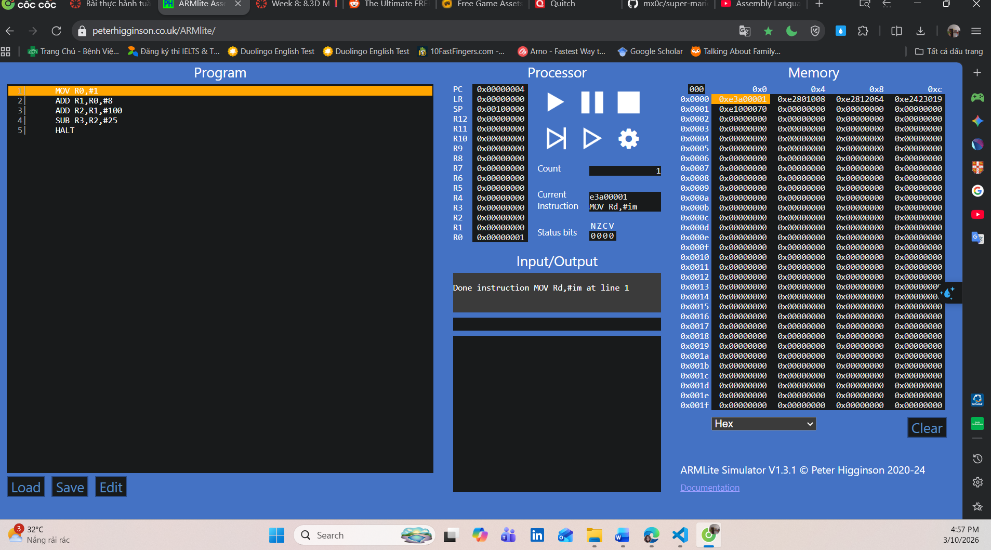
7.5.3 Task: Your 6 initial numbers are now 300, 21, 5, 64, 92, 18. Write an Assembly Program that uses these values to compute a final value of 294 (you need only use MOV, ADD and SUB). Place your final result in register R7 (don't forget the HALT instruction)
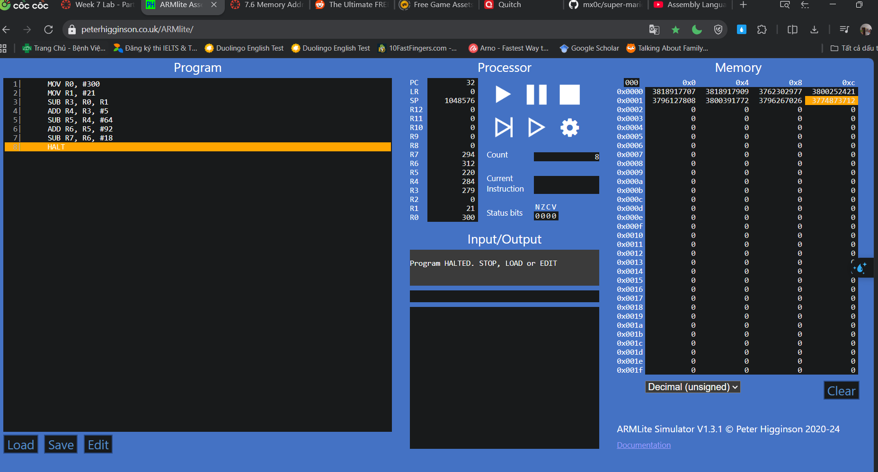
7.5.4 Task: Write your own simple program, that starts with a MOV (as in the previous example) followed by five instructions, using each of the five new instructions listed above, once only, but in any order you like – plus a HALT at the end, and with whatever immediate values you like.
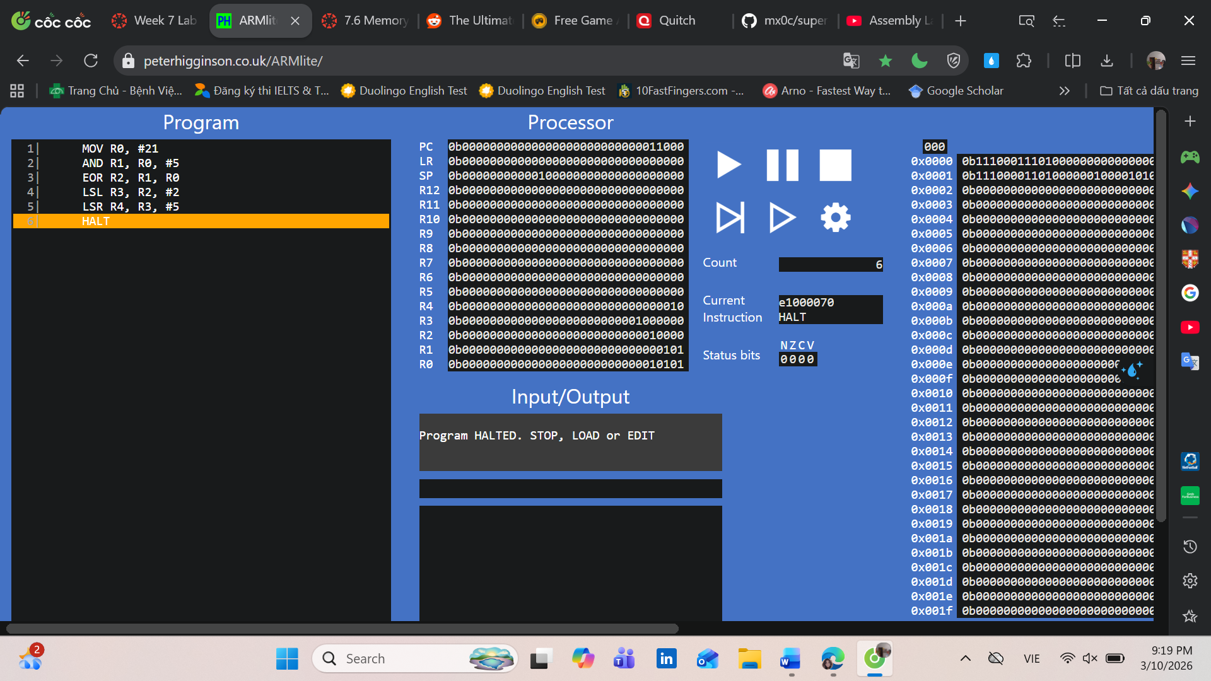
Instruction | Decimal value of the destination register after executing this instruction | Binary value of the destination register after executing this instruction
MOV R0, #21 | 21 | 0001 0101
AND R1, R0, #5 | 5 | 0000 0101
EOR R2, R1, R0 | 16 | 0001 0000
LSL R3, R2, #2 | 64 | 0100 0000
LSR R4, R3, #5 | 2 | 0000 0010
HALT
Task 7.5.5 Lets play the game we played in 7.5.3, but this time you can use any of the instructions listed in this lab so far (ie,. MOV, AND, OR, and any of the bit-wise operators).
Your six initial numbers are: 12, 11, 7, 5, 3, 2 and your target number is: 79
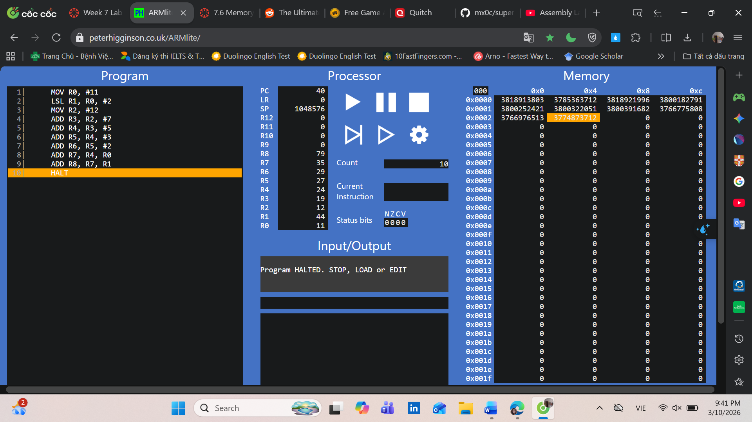
When the program is complete, take a screen shot of the code and the register table and paste into your submission document.
Instruction | Decimal value of the destination register after executing this instruction | Binary value of the destination register after executing this instruction
MOV R0, #11 | 11 | 0000 1011
LSL R1, R0, #2 | 44 | 0010 1100
MOV R2, #12 | 12 | 0000 1100
ADD R3, R2, #7 | 19 | 0001 0011
ADD R4, R3, #5 | 24 | 0001 1000
ADD R5, R4, #3 | 27 | 0001 1011
ADD R6, R5, #2 | 29 | 0001 1101
ADD R7, R4, R0 | 35 | 0010 0011
ADD R8, R7, R1 | 79 | 0100 1111
HALT

Task 7.5.6: Let's play again !
Your six initial numbers are: 99, 77, 33, 31, 14, 12 and your target number is: 32
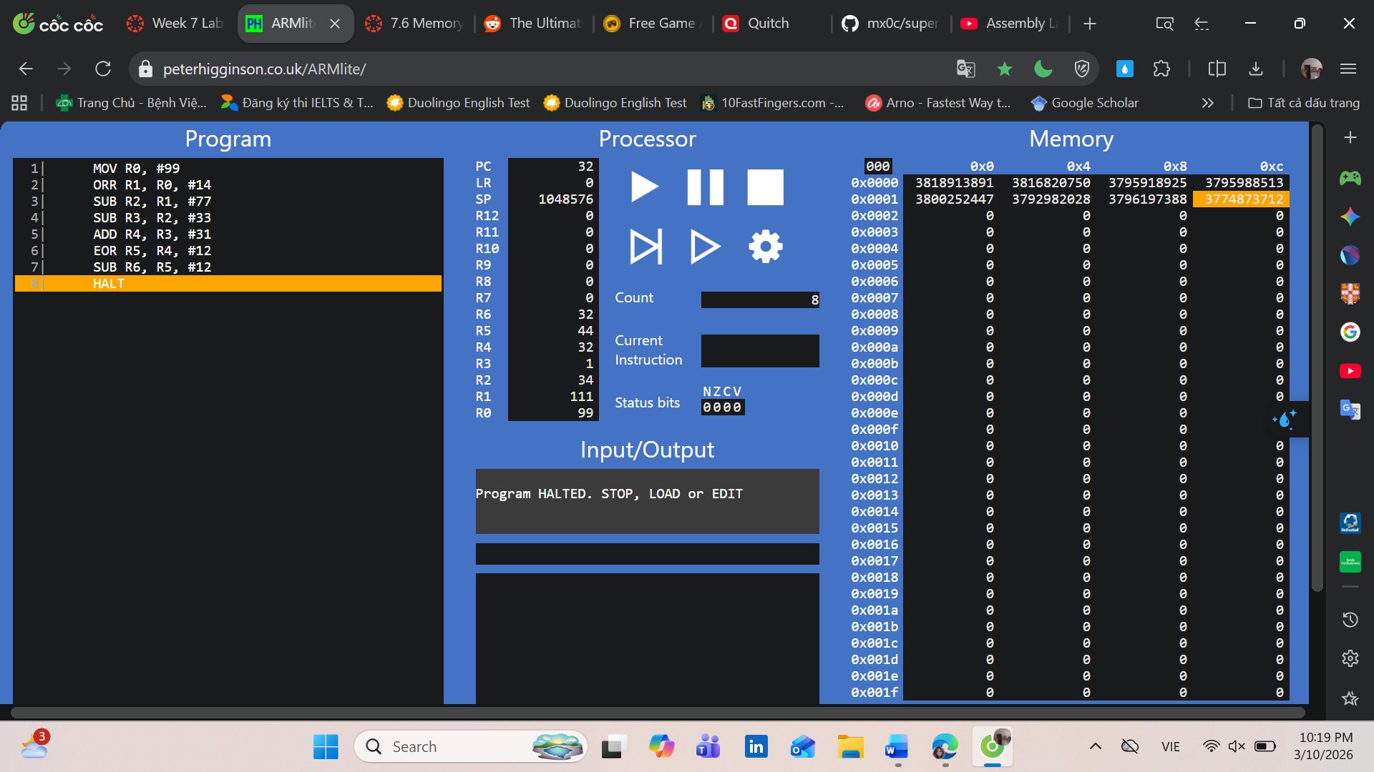
When the program is complete, take a screen shot of the code and the register table and paste into your submission document.
Instruction | Decimal value of the destination register after executing this instruction | Binary value of the destination register after executing this instruction
MOV R0, #99 | 99 | 0110 0011
ORR R1, R0, #14 | 111 | 0110 1111
SUB R2, R1, #77 | 34 | 0010 0010
SUB R3, R2, #33 | 1 | 0000 0001
ADD R4, R3, #31 | 32 | 0010 0000
EOR R5, R4, #12 | 44 | 0010 1100
SUB R6, R5, #12 | 32 | 0010 0000
HALT
7.6.1 - Why is the result shown in R1 a negative decimal number, and with no obvious relationship to 9999 ?
The result becomes negative because the instruction LSL R1, R0, #18 shifts the bits of the number to the left by 18 positions. This moves the most significant bit (sign bit) into the leftmost position of the 32-bit register.
Since ARMLite displays numbers using two’s complement signed representation, when the sign bit becomes 1, the value is interpreted as a negative number.
Therefore, the result appears as a negative decimal number and does not seem directly related to the original value 9999.
7.6.3 - What is the binary representation of each of these signed decimal numbers: 1, -1, 2, -2
What pattern do you notice ? Make a note of these in your submission document before reading on.
The ARMlite simulator is using 2's Compliment to represent signed integer values. Recall from lectures how 2's Compliment works to get the negative version of a number:
- invert (or ‘flip’) each of the bits
- Add 1
Using 8-bit two’s complement:
- +1 → 00000001
- −1 → invert 00000001 → 11111110, add 1 → 11111111
- +2 → 00000010
- −2 → invert 00000010 → 11111101, add 1 → 11111110
Pattern: Negative numbers always start with a leading 1 (sign bit), and they are obtained by flipping all bits of the positive number and adding 1. This is why two’s complement is symmetric: it works both ways.
7.6.4 - Write an ARM Assembly program that converts a positive decimal integer into its negative version. Start by moving the input value into R0, and leaving the result in R1.
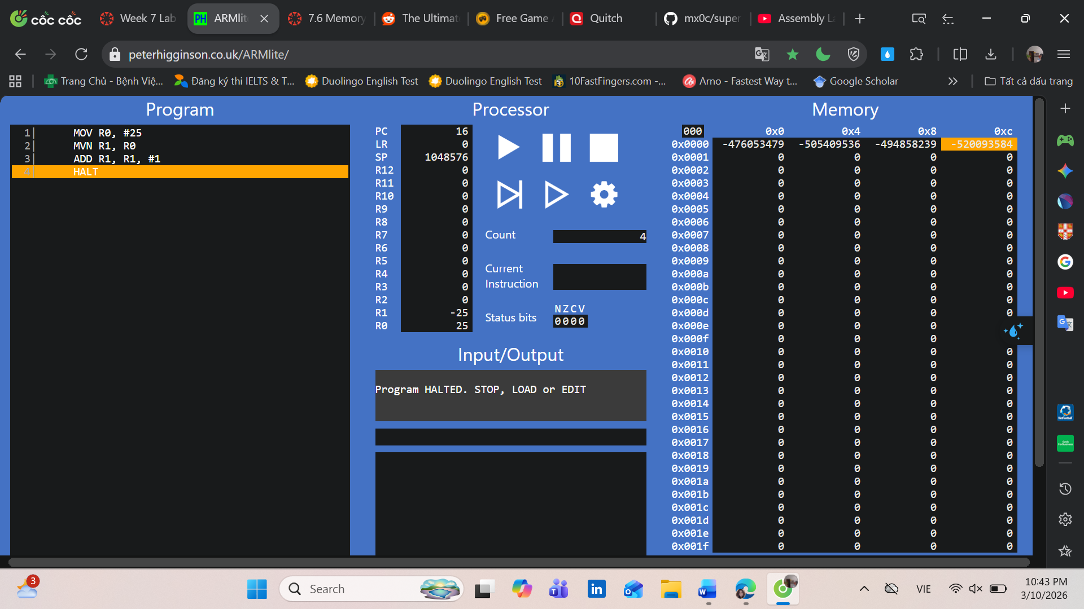
Take a screen shot showing your program and the registers after succesful execution, and paste into your submission document.
Using the program you wrote above, enter the negative version of the number you previously tested as the input (ie use the output of the previous test as the input).
When I enter the positive number (25), the program outputs −25 in R1. If I then enter −25 as the input, the program outputs +25.
This happens because ARMlite uses two’s complement representation for signed integers. The MVN instruction flips all bits, and adding 1 completes the conversion. Two’s complement works symmetrically: applying it to a positive number gives the negative, and applying it again to the negative gives back the positive.
What do you notice ?
All things working as they should be, you should see that the exact same 2's Compliment conversion works in both directions (ie positive to negative, and negative to positive).
The program correctly converts a positive decimal integer into its negative version using two’s complement. For example, input 25 in R0 produces −25 in R1. When the negative value (−25) is used as input, the program outputs +25. This demonstrates that two’s complement conversion works in both directions: positive to negative and negative to positive.

